Project Design Phase-II
Data Flow Diagram & User Stories

Date | 07-03-2026
Team ID | SWTID-2026-6567
Project Name | MicroGoal
Maximum Marks | 4 Marks

Data Flow Diagrams:
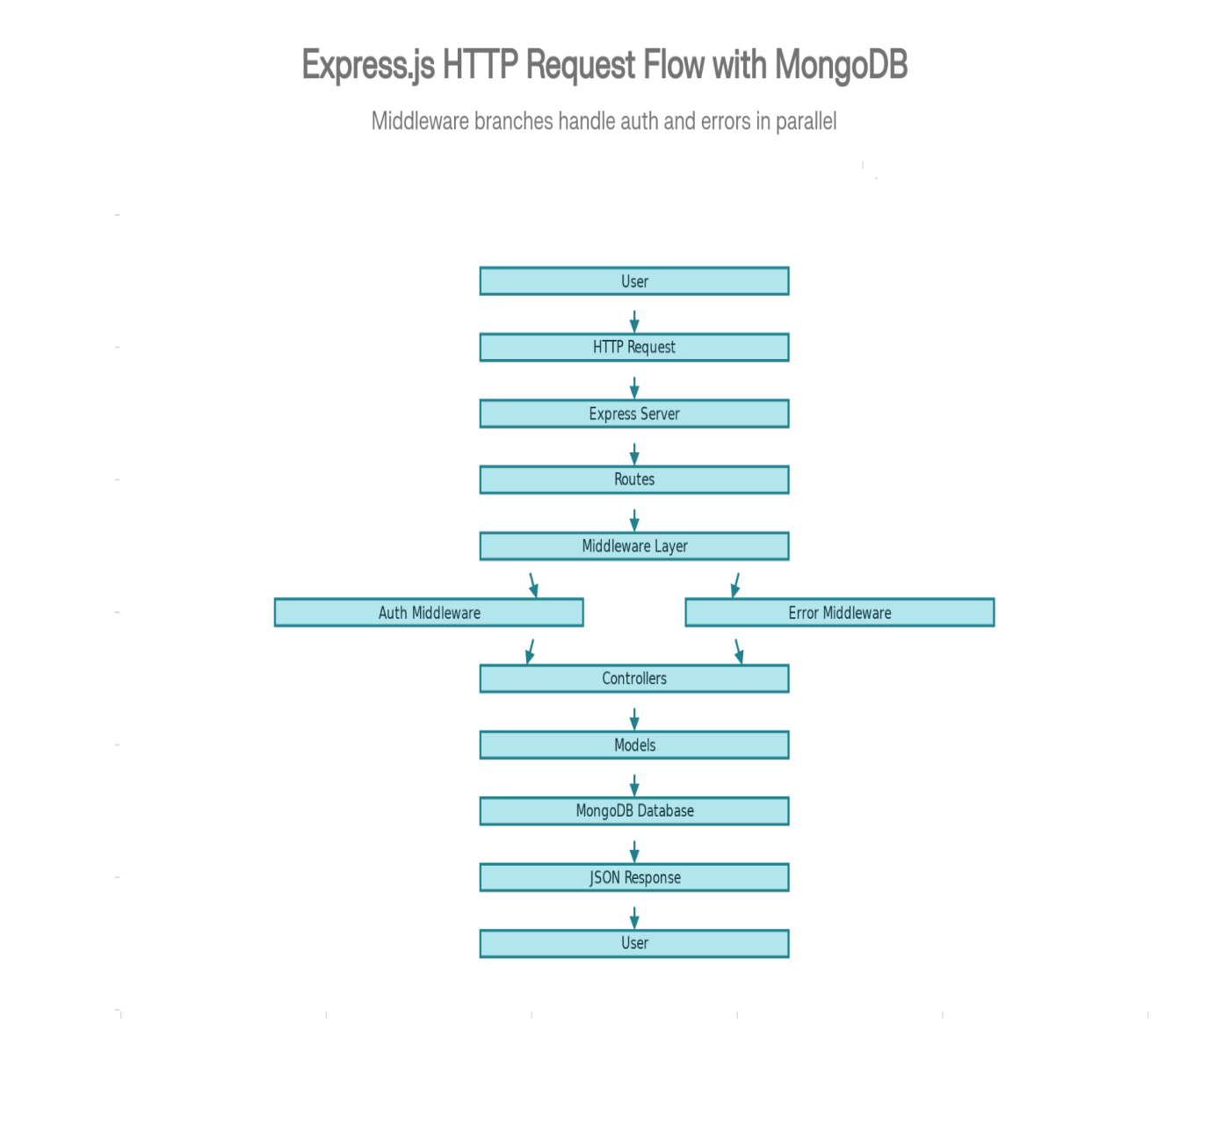
User Stories – MicroGoals Backend API:-

User Type | User Story Number | User Story / Task | Acceptance Criteria | Priority | Release
Customer (Web User) | USN-1 | As a user, I want to register an account so that I can access the system. | The user data is stored in the database and a success response is returned. | High | Sprint-1
Customer (Web User) | USN-2 | As a user, I want to log in securely so that I can access my personal goals. | A valid email and password generate a JWT token and return status 200. | High | Sprint-1
Customer (Web User) | USN-3 | As a user, I want to create a new goal so that I can manage my tasks. | The goal is saved in the database and a 201 status code is returned. | High | Sprint-1
Customer (Web User) | USN-4 | As a user, I want to view my goals so that I can track my progress. | Only authenticated users can access their own goals. | High | Sprint-1
Customer (Web User) | USN-5 | As a user, I want to update my existing goal so that I can modify my tasks. | The updated goal reflects correctly in the database. | High | Sprint-1
Customer (Web User) | USN-6 | As a user, I want to delete a goal so that I can remove completed or unnecessary tasks. | The goal is permanently deleted and a success response is returned. | High | Sprint-1
Customer (Web User) | USN-7 | As a user, I want my data to be protected so that other users cannot access my goals. | Unauthorized access returns a 401 Unauthorized error. | High | Sprint-1

Developer / Admin | USN-8 | As a developer, I want to test API endpoints to ensure they work correctly. | All endpoints return correct responses and status codes in Thunder Client. | Medium | Sprint-2
Developer | USN-9 | As a developer, I want centralized error handling so that errors are managed efficiently. | Errors are handled through middleware and proper messages are returned. | Medium | Sprint-2

